**DaemonSets:**

* Let’s say we want to have a monitoring app deployed in every node. Daemonset makes sure that.

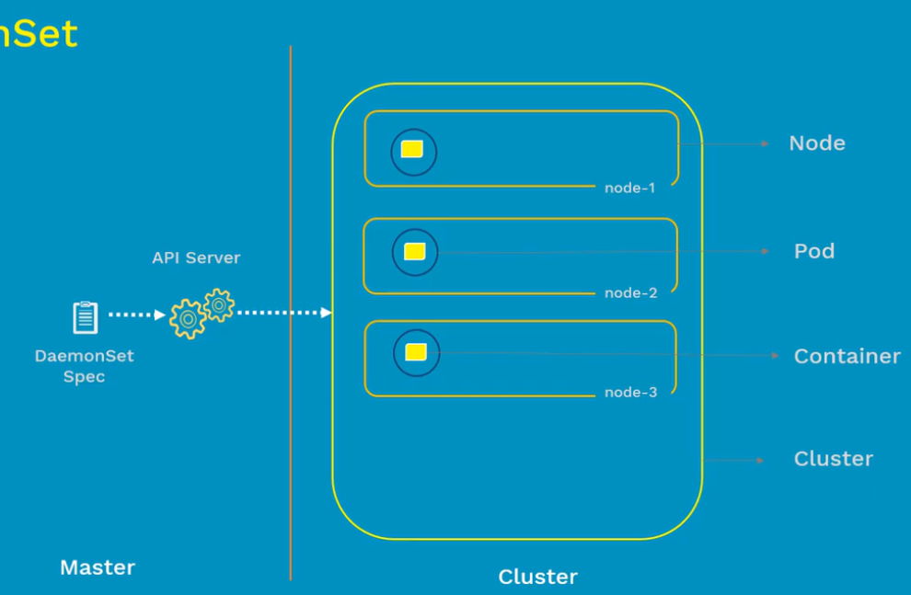

* If a new node added to the cluster. Daemonset monitors that and adds POD to that node.
* If node gets deleted. POD will also be deleted.
* If we delete the daemonset, all the PODS inside nodes will also be deleted.

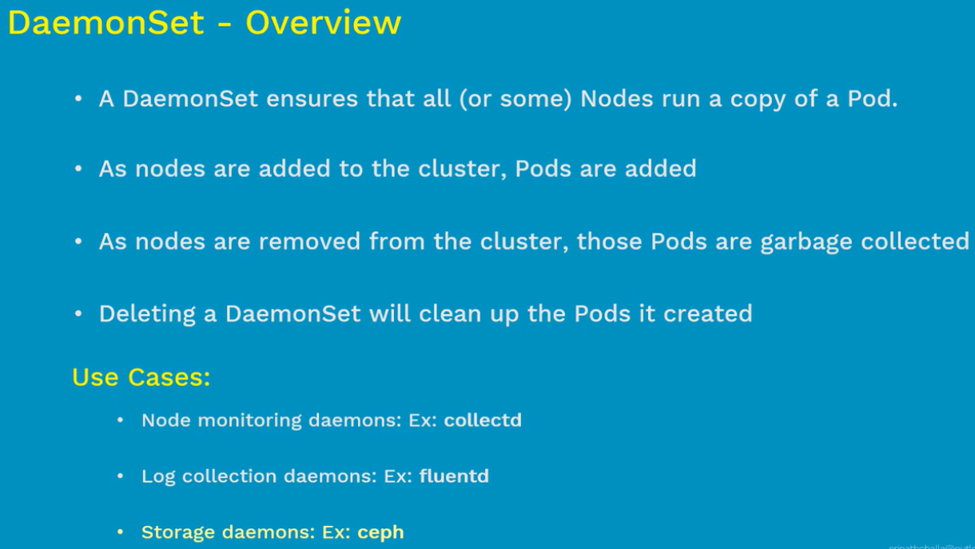

**Manifest file:**

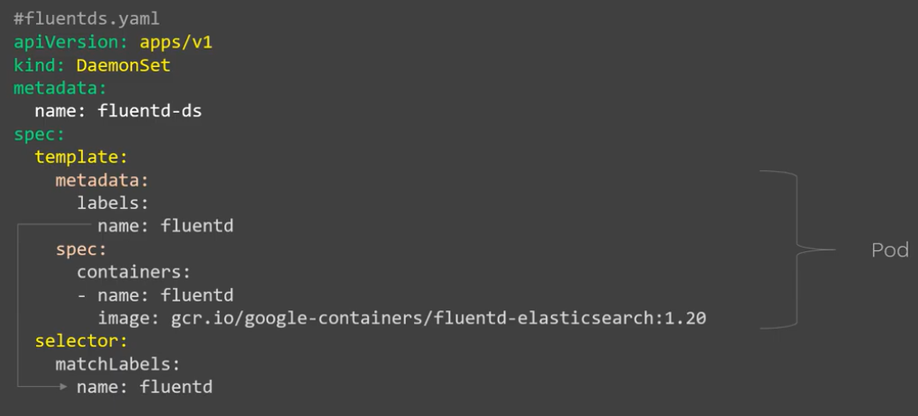

**Create & display:**

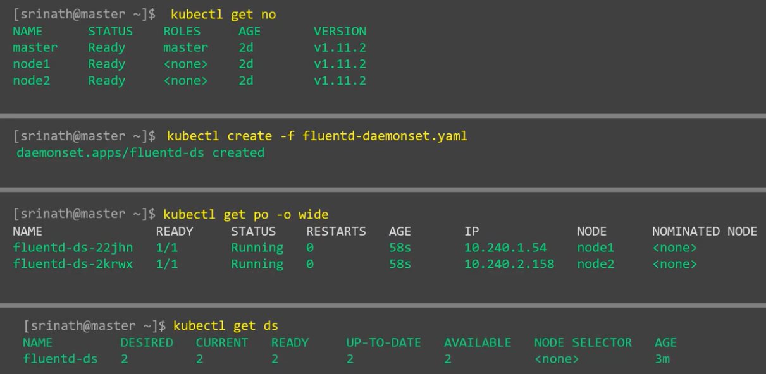

**Describe:**

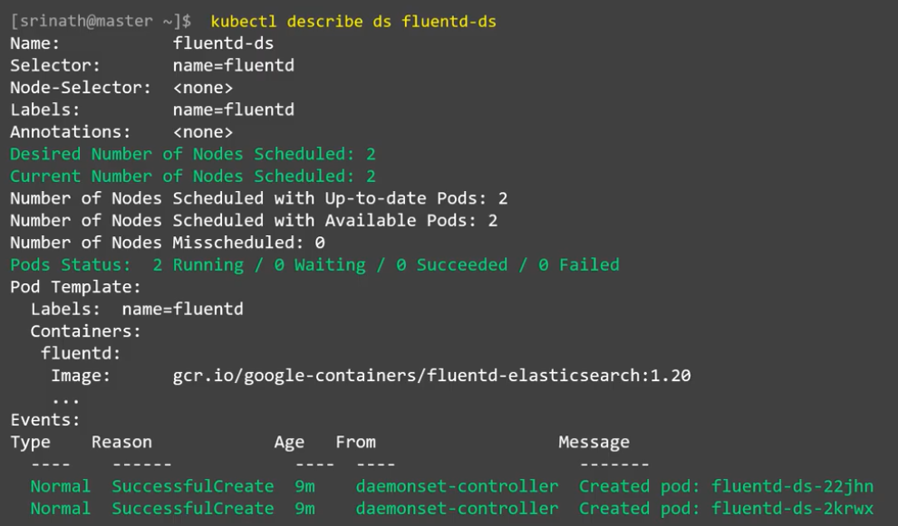

**Delete:**

